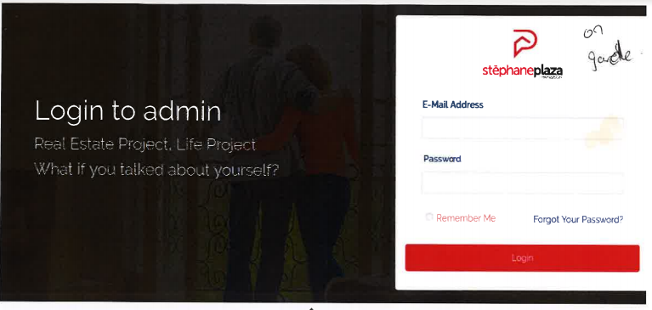

Put a HD photo

The customer wants photos that scroll. These are the photos of the various properties that stephane Plaza manages the seasonal rental.

Put the stephane plaza’s logo



LOGO



LOGO

Communauté Stéphane Plaza